i want to perform the infra task where launch an one ec2 .in that enable the monitoring .memory and disk matrics should be created .host an application on ec2.attach an loadbalancer to ec2.also perform autoscaling .connect rds to ec2..create vpc manually.

You will manually:
- Create a VPC with subnets, IGW, route tables, etc.
- Launch an EC2 instance with monitoring enabled.
- Install an application (e.g., a sample web app).
- Set up CloudWatch monitoring (including memory and disk).
- Create an RDS instance and connect it to EC2.
- Attach a Load Balancer.
- Enable Auto Scaling.

Step 1: Create a Custom VPC
- Login to AWS Console
- Go to VPC > Your VPCs > Create VPC
  - Name: MyCustomVPC
  - IPv4 CIDR: 10.0.0.0/16
  - Tenancy: Default → Create
- Go to Subnets > Create subnet
  - Name: PublicSubnet
  - VPC: MyCustomVPC
  - AZ: ap-south-1a (or your preferred)
  - CIDR: 10.0.1.0/24
Repeat for PrivateSubnet:
  - CIDR: 10.0.2.0/24
- Go to Internet Gateways > Create IGW
  - Name: MyIGW → Create
  - Attach to VPC: MyCustomVPC
- Go to Route Tables > Create Route Table
  - Name: PublicRT, select MyCustomVPC
  - Edit routes → Add 0.0.0.0/0 → Target: MyIGW
  - Edit subnet association → Select PublicSubnet
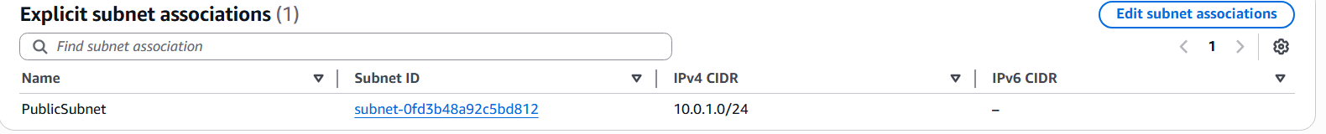
Step 2: Launch an EC2 in Public Subnet
- Go to EC2 > Launch instance
  - Name: WebServer
  - AMI: Ubuntu or Amazon Linux
  - Instance type: t2.micro
  - Key pair: Create new or use existing (download .pem)
  - Network: MyCustomVPC, Subnet: PublicSubnet
  - Auto-assign Public IP: Enable
  - Security Group:
    - Allow SSH (22) from your IP
    - Allow HTTP (80) from Anywhere
  - Click Advanced > Monitoring: Enable detailed monitoring
  - Launch

Step 3: SSH & Install Application (e.g., NGINX)
Use Xshell or Terminal:
ssh -i C:\Users\pratiksha.tapkir\Downloads\new1.pem ec2-user@13.233.165.109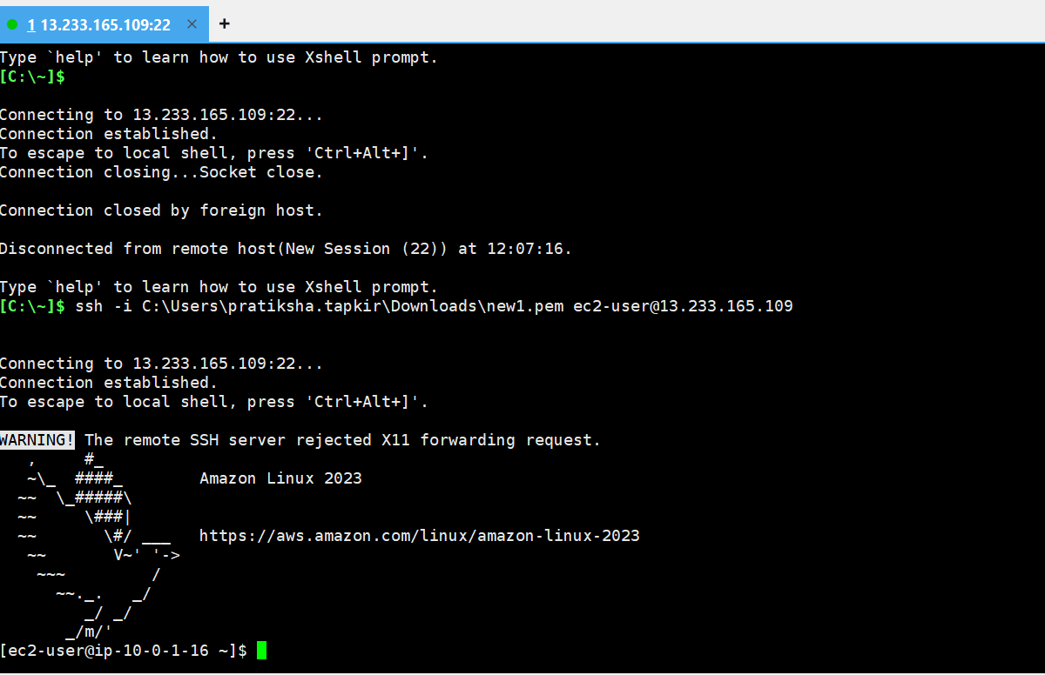

Install Web Server:
# For Amazon Linux
sudo yum update -y
sudo yum install nginx -y
sudo systemctl start nginx
sudo systemctl enable nginx
echo ‘<h1>Welcome to my App!</h1>’ | sudo tee /usr/share/nginx/html/index.html
Check from browser: http://<EC2-Public-IP>
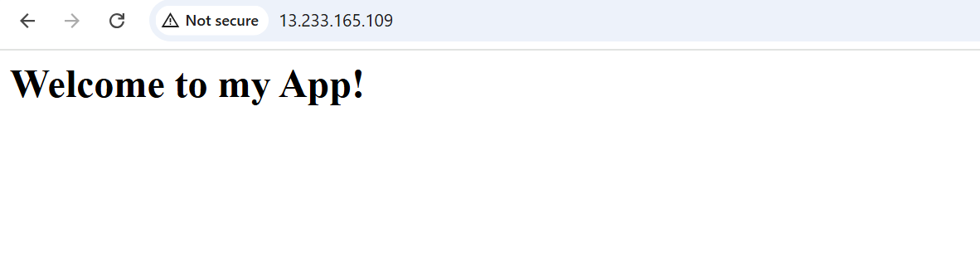
Step 4: Enable CloudWatch Memory & Disk Metrics:
Install CloudWatch Agent:
sudo yum install amazon-cloudwatch-agent -y
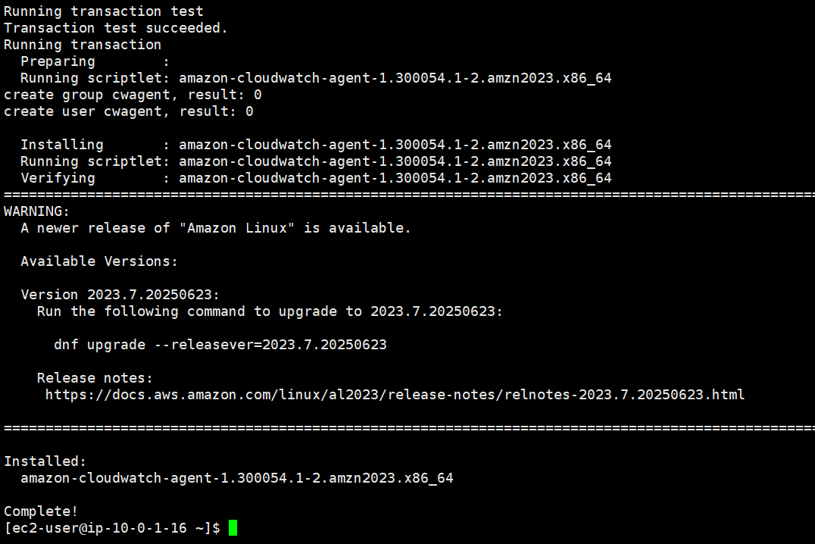

Step 5: Create and Connect RDS to EC2
- Go to RDS > Create database
  - Choose Standard > SQL Server or MySQL (based on preference)
  - DB Name: MyAppDB
  - VPC: MyCustomVPC
  - Subnet Group: Create with PrivateSubnet
  - Public access: No
  - VPC Security group: Allow inbound port 3306 from EC2 SG
Step 5: Create and Connect RDS to EC2
- Go to RDS > Create database
  - Choose Standard > SQL Server or MySQL (based on preference)
  - DB Name: MyAppDB
  - VPC: MyCustomVPC
  - Subnet Group: Create with PrivateSubnet
  - Public access: No
  - VPC Security group: Allow inbound port 3306 from EC2 SG
1. Create a Private Subnet (if not done)
- Go to VPC > Subnets > Create subnet
  - VPC: MyCustomVPC
  - AZ: ap-south-1a → PrivateSubnet1 (e.g., 10.0.2.0/24)
  - AZ: ap-south-1b → PrivateSubnet2 (e.g., 10.0.3.0/24)
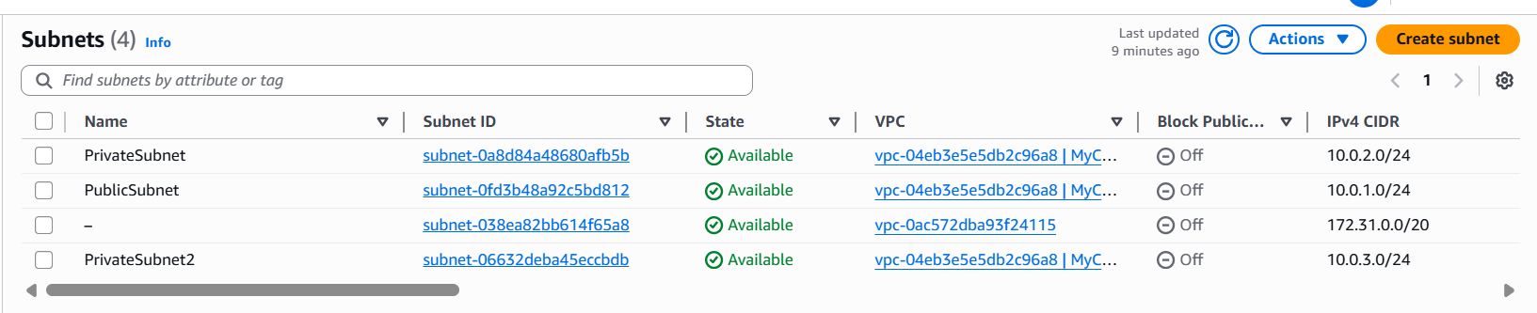
2. Create a DB Subnet Group
- Go to RDS > Subnet Groups > Create
  - Name: MyDBSubnetGroup
  - VPC: MyCustomVPC
  - Select both private subnets (must be in 2 AZs)

3. Create the RDS Instance
- Go to RDS > Databases > Create database
  - Engine: MySQL
  - Template: Free tier
  - DB name: MyAppDB
  - Username: admin, Password: yourpassword
  - VPC: MyCustomVPC
  - Subnet Group: MyDBSubnetGroup
  - Public Access: No
  - Availability Zone: No preference
  - Security Group: Create new or select one that:
    - Allows port 3306 (MySQL)
    - Source: EC2 security group

Step 6: Add Load Balancer
- Go to EC2 > Load Balancers > Create
  - Type: Application Load Balancer
  - Name: MyALB
  - Scheme: Internet-facing
  - Subnets: Select PublicSubnet(select two public subnet)
  - Security Group: Allow HTTP (80)
  - Target Group: New target group → register EC2
  - Listener: HTTP → Forward to target group
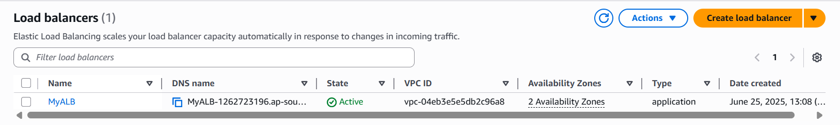
Test via: http://<ALB-DNS>

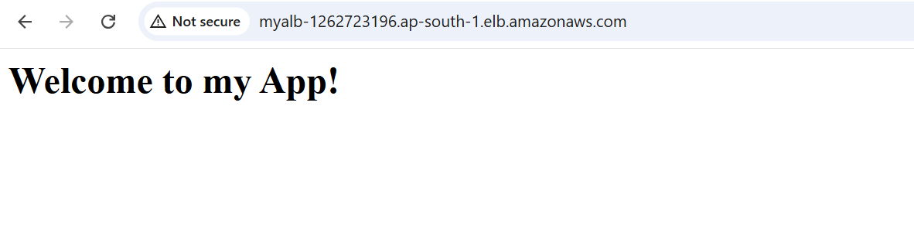
Step 7: Setup Auto Scaling Group
- Go to EC2 > Auto Scaling Groups
  - Create Auto Scaling Group
  - Use existing Launch Template or create new
  - VPC: MyCustomVPC, Subnet: PublicSubnet
  - Attach to Target Group of Load Balancer
  - Scaling policy: Target tracking
    - Metric: Average CPU > 60% → Add 1 instance
    - Cooldown: 300 sec

